Chapter 7, Problem 46.

For the circuit in Fig. 7.113, i_{s}(t) = 5u(t). Find v(t).

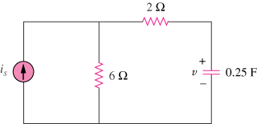

Figure 7.113
For Prob. 7.46.

